|  |  |
| --- | --- |
| **Name:- Aryan Dilipbhai Langhanoja** | **Roll Number:- 92200133030** |
| **Subject Name and Code:-** Foundation Skills On Sensor Interfacing (01CT1103) | **Date of Experiment:- 13-11-2023** |

|  |  |
| --- | --- |
| Task:- |  |

* Interface wifi module with arduino uno development board and observe the temperature and humidty data on BLYNK application.

|  |  |
| --- | --- |
| Components: |  |

* Arduino Uno R3
* Wi-fi Module Node MCU ESP8266
* CU ESP8266dule HC05DHT-11 Sensor
* Jumper Wires (Male To Male)
* Laptop Or PC

|  |  |
| --- | --- |
| About the Project:- |  |

* In this Project, We are going to interface DHT 11 sensor with Node MCU ESP8266 Wi-fi module with Arduino. In that we connect VCC to 5V and ground to GND. Signal Pin to any of GPIO Pin.

|  |  |  |
| --- | --- | --- |
| Output:- (you circuit implementation |  |  |

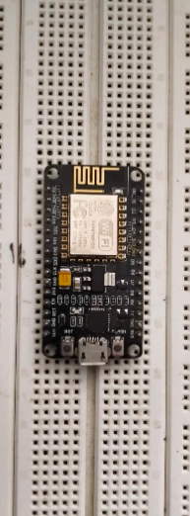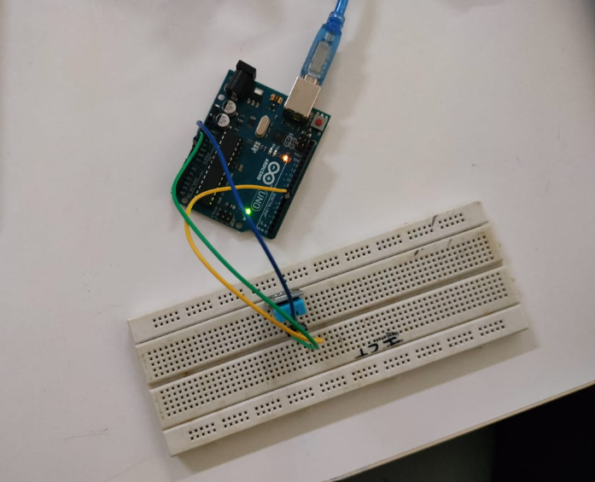

|  |  |
| --- | --- |
| Code:- |  |

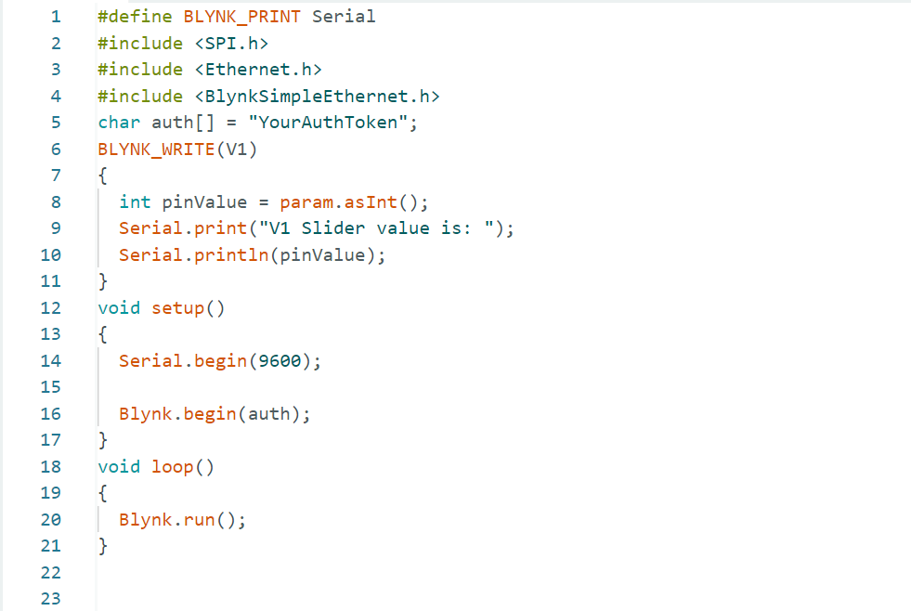

|  |  |
| --- | --- |
| Conclusion:- |  |

* In This Experiment, We Learnt That How to Interface DHT11 sensor with Arduino.